What Are Hoverboards? | Segways

To be honest talking, the Hoverboards UK we talk about today can't really suspend or drift. All things being equal, they use wheels to move over the ground thus "Self-Balancing Scooters" would really be a more exact name for them.
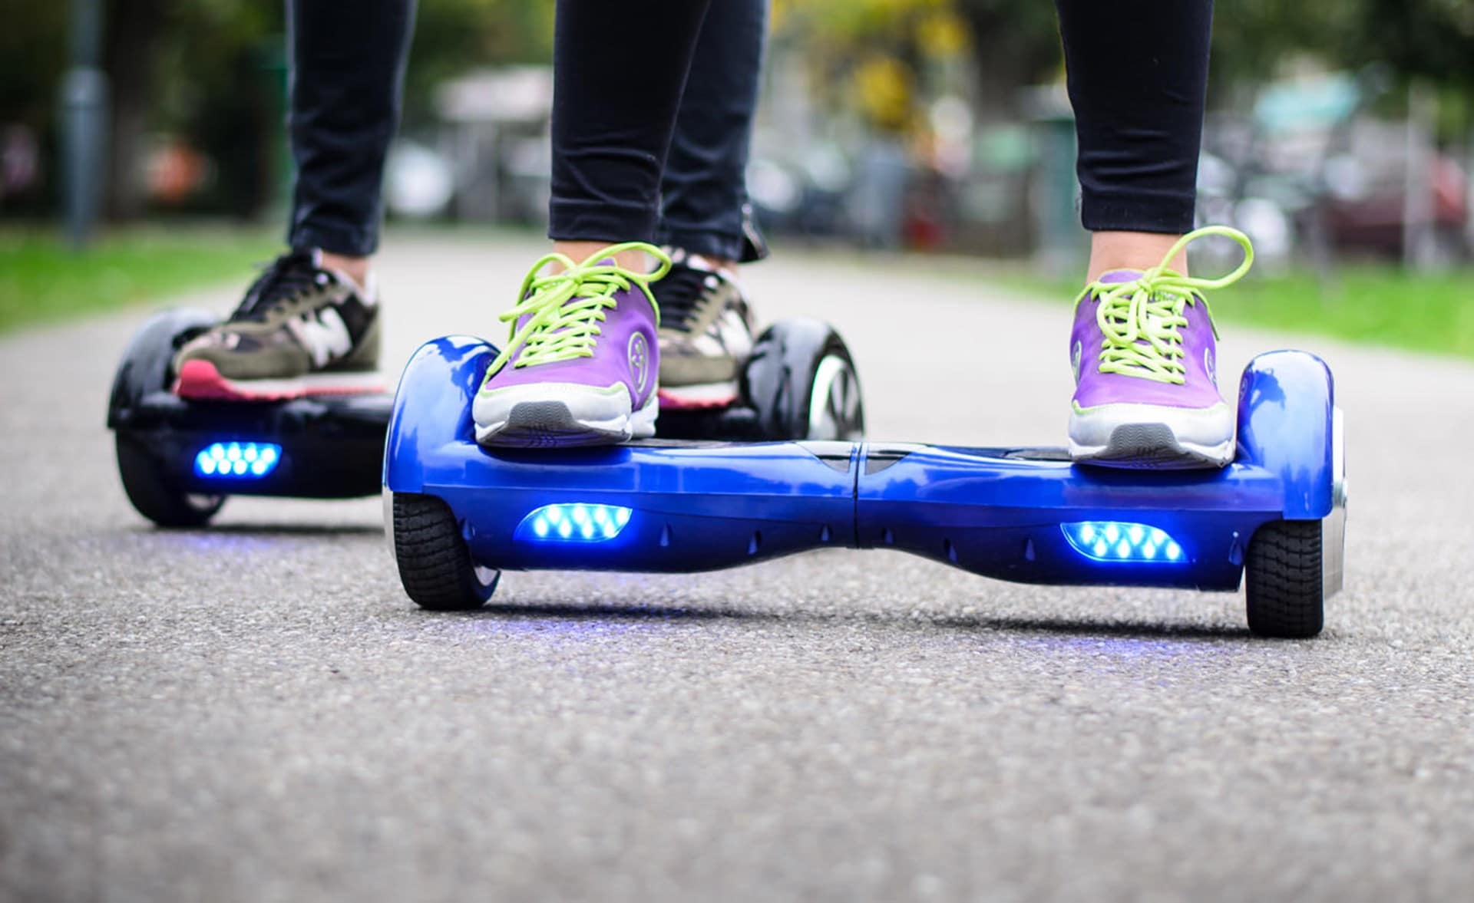
They regularly have two footpads with instinctive, forefront sensors to recognize even the smallest developments. They are extremely simple to control, pushing ahead when you lean forward and slowing down and switching when you recline.

Are Hoverboards Legal?
Not all over. Since increasingly more hoverboards have been sold, an ever increasing number of individuals are appropriately worried about the wellbeing of these vehicles.
The New York City Police Department proclaimed hoverboards unlawful and cautioned individuals that they could be met with fines and different punishments in the event that they're discovered riding them in the road.
The United Kingdom has adopted a comparative strategy. Self-adjusting bikes and other mechanized carriers are prohibited from walkways.
Both New York City and the United Kingdom are utilizing comparative understandings of the law to restrict the utilization of self-adjusting bikes in open regions. The explanation is that hoverboard riders could upset the progression of traffic in the event that they're utilized on walkways.
Here is no wellbeing on the off chance that you don't utilize and think about your item appropriately. What would it be a good idea for us to do when purchasing a self-adjusting bike? How would we forestall fire, blast and injury?
Prior to Buying a Hoverboard | Segways
Most importantly, ensure you purchase the hoverboard bike from a solid provider. A decent provider or store can ensure the quality and they have a severe assessment framework to test items prior to delivery to buyers.
There are heaps of stories and reports of hoverboard flames and blasts from the finish of a year ago, which are generally brought about by low quality batteries. Great providers will utilize Samsung batteries or other marked batteries.
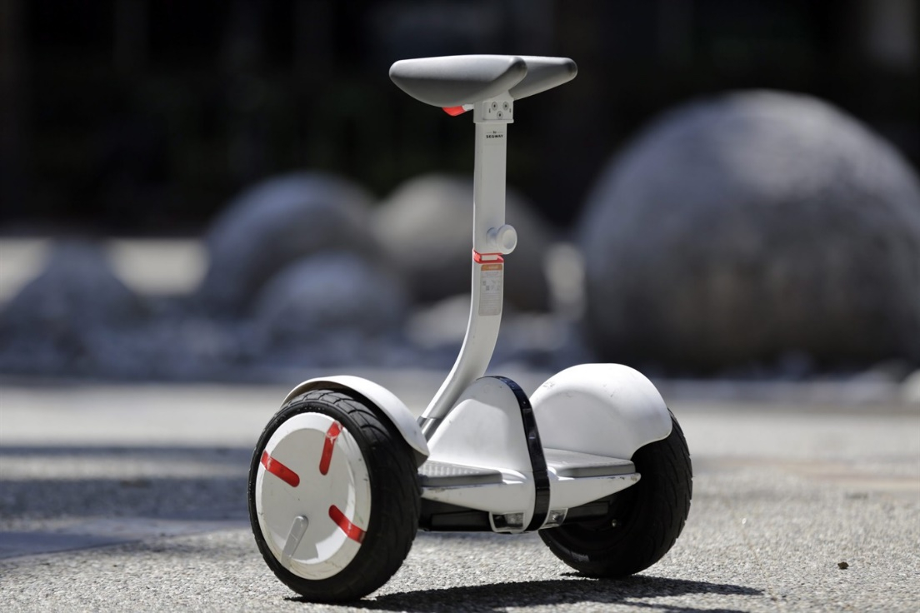
Furthermore, prior to submitting your request, you can ask with the provider on the off chance that you have any worry about the hoverboard.

In the wake of Buying a Hoverboard
In the event that you as of now have a hoverboard, at that point you ought to routinely checkup when it’s charging, and cease from charging it while you are resting around evening time or when you are not at home.
Security gear is exceptionally vital for the novices. Try not to rehearse in flimsy spots or in packed regions, you may fall and harm or hurt the individuals around you.
Obey and regard your nearby laws, don't ride the Hoverboard Cart where it has been prohibited, likewise be certain not to ride the units in the city.
As the most sweltering toys and Christmas presents for the finish of 2015, hoverboards can totally carry happiness to your entire family. They are so natural for to ride, all you require is 30 minutes of training and you're all set!
Scene 1-Birthday Gift
We've seen that numerous children overall are passing on for a hoverboard, so why not make their birthday additional unique?
Scene 2-Holiday Gift
The midyear occasions are when youngsters need to get all over town and seen. What amount would kids and adolescents like you, on the off chance that you could offer them a drift board to get them here and there this mid-year?
Scene 3-Christmas Gift
Hoverboards are the best endowments of a year ago, thus keep on being so in 2016. Everybody has had that fantasy to resemble superman and the hoverboards can (practically!) make that fantasy work out as expected. We accept that, once more, hoverboards will be most sultry present for Christmas 2016. (Hoverboards Christmas Sale)
Hoverboards are a sort of game item however they are additionally a whole lot more. You can float around on the sheets to see your companions. Or on the other hand you can ride with your family to the ocean for some natural air. You can likewise drift on the board with your GoPro to make recordings for your loved ones.

